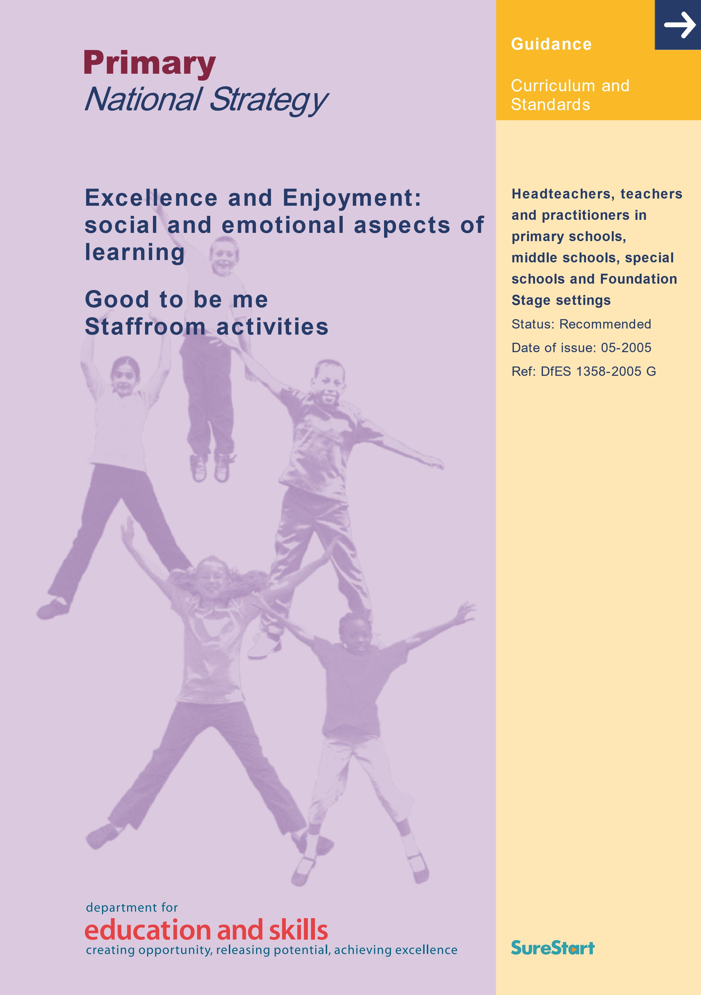
Disclaimer
The Department for Education and Skills wishes to make it clear that the Department and its agents accept no responsibility for the actual content of any materials suggested as information sources in this document, whether these are in the form of printed publications or on a website.
In these materials icons, logos, software products and websites are used for contextual and practical reasons. Their use should not be interpreted as an endorsement of particular companies or their products.
The websites referred to in these materials existed at the time of going to print. Users should check all website references carefully to see if they have changed and substitute other references where appropriate.

Purple set

Good to be me – activities for the staff group

Introduction
The following activities are designed to be carried out in the staff room to help adults to tune in to the strands of the theme at an adult level, and to experience at first hand some off the activities that the children will be engaging with at different stages.
These activities are designed to help you as a staff group to think about the issues involved in working with children on developing self awareness – understanding and managing feelings, understanding their own particular strengths, learning how to be assertive when they need to.
The key ideas and concepts behind this theme are:
Building emotional resilience
Children need to become resilient if they are to be healthy and effective life long learners.

Coping with anxiety and worrying
Worry and anxiety are major features in many children’s lives. Many children have good reasons to be anxious. Exploring worries is important.

Calming down
Although getting stressed, anxious or angry are important and useful emotions, sometimes these feelings can be overwhelming.

Assertiveness
The theme encourages children to become assertive – that is, able to recognise and stand up for their rights while recognising and respecting the rights of others.

Understanding feelings and how they influence behaviour
The theme explores the relationship between ‘thinking’ and ‘feeling’, and the way each impacts on our behaviour.
A good starting point for work within this theme is to be found in the booklets Conditions for learning (pages 38–45) and Learning to learn: progression in key skills (pages 14–25) from Excellence and Enjoyment: learning and teaching in the primary years (DfES 05182004 G). These might be used as background reading prior to the session. There are a number of suggested CPD activities in these materials which you may find helpful. Another useful resource is the Importance of emotions in the classroom session from the Primary National Strategy behaviour and attendance professional development materials (available from www.standards.dfes.gov.uk/primary/wholeschool/banda).
The following activities are designed to promote a more in-depth enquiry into some of the key thinking behind the theme.

Activity 1: understanding emotions
There are several parts to this activity, which might need to be explored in more than one staff meeting.

Part 1
Resources
Fight or flight resource sheet from the Yellow set: Year 4.

What to do
Thought shower what threats (real or imagined) children might experience in the classroom and in the school. Ideas might include the fear of getting things wrong, fear of other children laughing at them, and so on.
In pairs, read the resource sheet, which explains in simple terms the idea that human beings evolved in a dangerous world, where it was essential to have a ‘rapid response system’ (the emotional brain) that could respond very quickly to threat.
Nowadays the world is not so dangerous but our behaviour is still often influenced by this rapid response system when we feel threatened.
Consider the following questions:
- Can you think of a time when this has applied to you?
- Does this help you explain the behaviour of any of the children in your class or school?

Applying learning
In pairs, consider how the threats that children perceive or experience might be reduced. Agree ways to address and reduce these threats. Try out your ideas in the classroom and across the school.

Part 2

Resources
A copy of the learning opportunity ‘understanding my feelings’ from the Green set: Year 5 and the accompanying resource sheet Maggie’s story.
The learning opportunity ‘understanding my feelings’ from the Green set: Year 6.
A copy of the Emotional barometer (from the whole-school resource file) for each person.
Copies of the handouts Sam’s story and Peter’s story for each person.

What to do
Read the following short story (from the Green set: Year 5):
Paul was playing out. He saw a large shadow coming towards him from round a corner. He felt really scared.
He was ready.
A person came round the corner. Paul ran.
The person grabbed his arm. Paul hit the person very hard. At that moment he realised who it was. It was his big brother coming to get him for tea.
Talk together in pairs to agree an answer to this question:
- Why did Paul hit his brother even though he loved him very much and didn’t want to hurt him?
One explanation is that he was reacting with his rapid response system – his emotional brain. The emotional part of his brain responds to potential danger more quickly than the more careful thinking part of the brain. Paul responded by hitting before he had a chance to recognise his brother.
Read Maggie’s story from the Green set: Year 5 resource sheet.
Thought shower all the words you can think of that describe the emotions that Maggie felt in the story.
In pairs, talk about the following question:
- Why did Maggie respond in this way, even though when she had calmed down she knew it was wrong?
One explanation is that Maggie was becoming increasingly emotionally aroused (she probably wasn’t even aware of what was happening). The boy treading on her toe was the last straw. The thinking part of her brain was overwhelmed by the emotional part and she hit out without thinking things through.
Read the story of Sam from the handout, and as you do so, use the emotional barometer to show how she was feeling in various parts of the story.
Repeat this activity as you read the story of Peter.
Consider the following questions:
- Why did Sam respond in the way she did when Peter told her to move?
- Why did Peter respond in the way he did when Sam refused to move?
- What can Peter do to help prevent the same or a similar thing happening in the future?
Try to think of strategies he might have used in the classroom:
to help him stop and think and calm down before responding; to avoid confrontation with Sam; to help Sam understand her own feelings; to start the day in a positive way.

Applying learning
Agree to implement some of the strategies you suggest. Try them out and review whether they made a difference.

Part 3

Resources
Resource sheet Overwhelmed by emotions from the Green set: Year 6.
The graphs on the resource sheet represent our level of arousal in frightening situations and when we are overwhelmed by emotions.

What to do
Look together at the graphs. In pairs, think of a scenario or story to go with each of the graphs.

Applying learning
What are the implications for the school if it takes at least an hour for a child to calm down after they have been overwhelmed by their emotions?
What are the implications if it takes at least an hour for adults to calm down after they have been overwhelmed by their emotions – for example, after being involved in an angry confrontation with a child?

Activity 2: relaxation

What to do
You might want to use a round to start this activity:
When I am stressed I calm down by …
The SEAL materials are based upon the idea that there are three key ways of calming down:
- distraction, by moving to a new place away from whatever is causing the stress or by doing something entirely different;
- exercise;
- relaxation.
How do the ways you choose to calm down fit into the categories?
Invite someone in to help you relax. Ideas might include, for example, Indian head massage or aromatherapy. Alternatively you could as a staff group use this visualisation from the Theme 5 materials (Yellow set: Year 3).
Make sure you are sitting comfortably with your feet flat on the ground and your eyes shut.
‘Imagine you are in your special place. You look around it. Think about all the things that you can see. Think about what you can hear. You reach out to touch the things that are near you. You think about how lovely it is to be in your special place and this is making you feel happy and content. Your body is beginning to relax.’ (Provide a few minutes to relax.) ‘It is now time to leave your special place, so you get up slowly. Turn around and take one look before you go.’ (Leave a couple of seconds then continue.) ‘When you are ready, open your eyes and look around the classroom. You might like to talk to the person next to you.’

Activity 3: assertiveness

Resources
Lion, Mouse, Fox and Human resource sheet (Yellow set: Year 3).
Assertiveness poster from the whole-school resource file.

What to do
Read the story of Lion, Mouse, Fox and Human.
Agree on the moral of the story and then list the strategies that Human used to successfully resolve the difficulty.
Look at the Assertiveness poster.
Read the story of Faye:
Faye is teaching a literacy lesson when Mr. Loak, the headteacher, enters. He is obviously in quite a state about something and starts to talk angrily to Faye in front of the class. He is saying something about an important piece of planning that must be posted to Ofsted before the end of the day. He says that Faye is the only teacher who hasn’t provided it. She suspects that he must have told staff about it during the staff meeting when she was off sick.
Mr. Loak says that Faye must do it at lunchtime, but she has already planned to run a circle of friends group to support a child with difficulties. The last meeting had to be cancelled because she was unwell.
Use the learning from the Lion, Mouse, Fox and Human story and the Assertiveness poster to decide how Faye might respond in each of the roles – Lion, Mouse, Fox and Human.
What sort of a person are you as a parent and at work – Lion (aggressive), Mouse (timid or whiney), Fox (sneaky) or Human (assertive)?

Applying learning
As a whole-staff group, summarise what you have learned during the activity.
In pairs, write an assertive script for use in the classroom or playground. This might be for when a child is reluctant to carry out an instruction. Use the script in class and report back on how well it worked.

Activity 4: worrying

Resources
The book The Huge Bag of Worries by Virginia Ironside (Hodder Wayland) ISBN 075 002 1241, if you have it.
Wormwart’s cure for worrying resource sheet (Green set: Year 6).

What to do
In the materials we define worrying as when our thoughts get stuck in a cycle of unproductive thought and we are unable break out into more productive problem solving. Having a problem becomes a worry when we don’t think about the solution but repeatedly think about the problem itself and possible negative outcomes.
You might like to start thinking about worrying by reading The Huge Bag of Worries.
Think about the questions:
- Do you ever worry? What is your worry? If you are happy to do so, share your worry with a partner.
- What worrying thoughts go with your worry?
Use Wormwart’s cure on your worry. It might help to go through this worked example first before you explore one of your own worries:
‘I worry when my daughter goes out late at night. I worry in case she is attacked on her way home.’ This is how the cure might work:
Catch that worry! I am feeling worried.
Have a good look and check that it is a Useless Worry and not a Useful Thought. A useless worry – she is 21, it is only 11 o’clock, she is out and I can’t do anything about it.
Last time things were OK … She often goes out until this time. She has always been OK before.
That isn’t true because … She is sensible and will get a lift with her friends. She knows to phone me if she is stuck without a lift.
That is really rare … Not many people get attacked around here.
You don’t get … attacked when you are with a group.
What do you think the children in your class worry about? Here are some possibilities:
‘I’m no good at maths. Miss will be cross and I will feel stupid in front of the class.’
‘My mum is at home with my baby sister. She will forget about me.’ How might you help them turn their worry into a useful thought?

Applying learning
As a staff group discuss how children are supported when they are feeling worried. Set up a Worry Box in class. Treat the worries confidentially (within the bounds of child protection) and follow them up with the children concerned.

Activity 5: building emotional resilience

What to do
Emotional resilience rests on many factors that include:
feelings of self worth; feelings of competence; learned optimism; feelings of autonomy;
the ability to bounce back in the event of failure; the ability to take sensible risks.
In small groups, consider each of the factors above and suggest ways in school and in your classroom that you help to build emotional resilience in the children in your class. How might you do this even more effectively?
Applying learning
Try out some of the ideas you have suggested.

Handout

Sam’s story
Sam had a bad morning. She had a row with her mother again. Her mother said that if things didn’t get any better she’d get Marian to come to see her. Marian was the social worker and Sam knew what that meant. Last time things were bad she had gone to live in a foster family. They were OK, but Sam had missed her mum and brothers terribly.
Sam set off for school. She was keen to do well but didn’t find work easy. When she got there she chatted with her friends about what they had been doing the night before. She almost forgot about the argument with her mum until it was literacy. She had to move classes and none of her friends were in the group with her. She knew it was because she found the work harder than they did.
She sat down at the nearest table and started to think. She thought about the foster family and how nice they were to start with. That was until she started to have rows with their son. She could remember lying in bed wanting her mum so much.
It took a while for her to realise that the teacher was talking to her. He might have been talking to her for a while but she hadn’t heard. He was walking towards her and now he was shouting at her and wagging his finger at her, just like her mum did. He was saying how there would be trouble if she didn’t move.
Before she had even thought about it she was standing up. There was silence all around her and everyone was looking at her. Then she heard herself saying, ‘P--off, just leave me alone.’ She knocked the pencil pot off the desk as she stormed out.

Peter’s story
Peter had a bad morning. His 5-year old son had played up really badly. He often wondered how it was that he had few difficulties managing a class of 30 Year 6 pupils when he found it so hard to get his son to hurry up and get ready for school in the mornings. When he eventually got his son in the car and turned the ignition on, it had spluttered and refused to start. It took him about half an hour messing around under the bonnet before he eventually set off. During the entire journey his son moaned about having to go to the child minder’s after school.

Things didn’t get much better once he got to school. It had been raining in the night and his classroom had sprung a leak. There was water all over his desk. Some of the children’s work had been ruined. Peter knew this would get the day off to a really bad start. After registration he had the weaker literacy group. They were a real handful. He had hoped to have everything ready for the group but now this wasn’t possible.
The class came in for the literacy group. He felt poorly prepared and had the beginning of a headache. He explained about the leak but some of the children were very upset.
He asked the class to get into their small groups. After the usual disturbance, they were ready to start. Then he noticed Sam. She was sitting on an empty table and had quite obviously not bothered to move.
He walked towards Sam. She was looking at him with a blank stare and seemed to be saying ‘You can’t make me move’. Before he had even thought about what to do he had launched in and heard himself saying, ‘Get into your group or you’ll be sorry.’ He was shouting, too.
Sam wasn’t usually too much of a problem. She didn’t always concentrate in class, but she usually did what she was told with a little extra prompting. But today she got up, swore at him, threw the pencil pot on the floor and stormed out.

